Installation Server



Senstable 2

Ziwe Zhang - 0984223

Index

Setup Webpage 3

Setup NodeJS server 4

Setup database 6

# Setup Webpage

To setup a webpage we’ll need to install some software:

sudo apt update

sudo apt upgrade

sudo apt install apache2

sudo apt install php

sudo apt install libapache2-mod-php

When it asks if you want to continue just type ‘y’ and press enter.

Afterward we need to go to the directory ‘/var/www/html’:

cd /var/www/html

Remove ‘index.html’

sudo rm index.html

Then copy the given files to this directory using something like FileZilla.



# Setup NodeJS server

Go to the directory ‘/var/www’

cd /var/www

create a directory called ‘nodejs’:

sudo mkdir nodejs

Make sure you’re in the directory you just made before you install the packages:

cd /var/www/nodejs

Install NodeJS:

sudo apt-get install nodejs

Install npm for the packages we need to install:

sudo apt install npm

Install the packages we need to make the web sockets work:

sudo npm install body-parser

sudo npm install express

sudo npm install ws

Copy and paste the given file named ‘server.js’ in the nodejs directory, it should look like this:



Next, we’re going to install PM2. This is going to automatically start the NodeJS server when we boot up the Raspberry Pi and if it crashes it will restart the server.

We will use npm to install PM2 globally -g.

sudo npm install -g pm2

To start ‘server.js’ with PM2:

pm2 start server.js

You’ll see something like this:

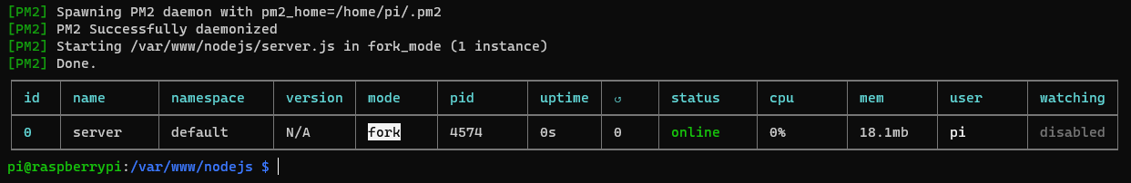

The pm2 startup command will generate a script that will lunch PM2 on boot together with the applications that you configure to start.

pm2 startup systemd

This will generate the following:



Copy the generated command and run it.

sudo env PATH=$PATH:/usr/bin /usr/local/lib/node_modules/pm2/bin/pm2 startup systemd -u pi --hp /home/pi

This created a system unit that will start PM2 on boot. When the system will boot PM2 will resurrect from a dump file that is not created yet. To create it run the following:

pm2 save

This will save the current state of PM2 (with server.js running) in a dump file that will be used when resurrecting PM2.

That's it! This will keep the server running and will start the server when you boot up the Raspberry.

Using pm2 list or pm2 status you’ll be able to see the status of the server.

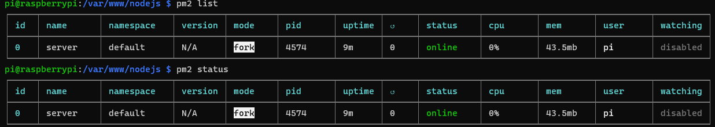

# Setup database

We’ll need a database to keep track of which input relates to which output.

Therefor we need to install some packages:

sudo apt-get install mysql-server mysql-client

When it is installed, we’re going to make a root account for the database:

sudo mysql_secure_installation

Follow the steps given in the terminal and create a password for the root account.

When it asks a few questions say ‘yes’ to all of it.

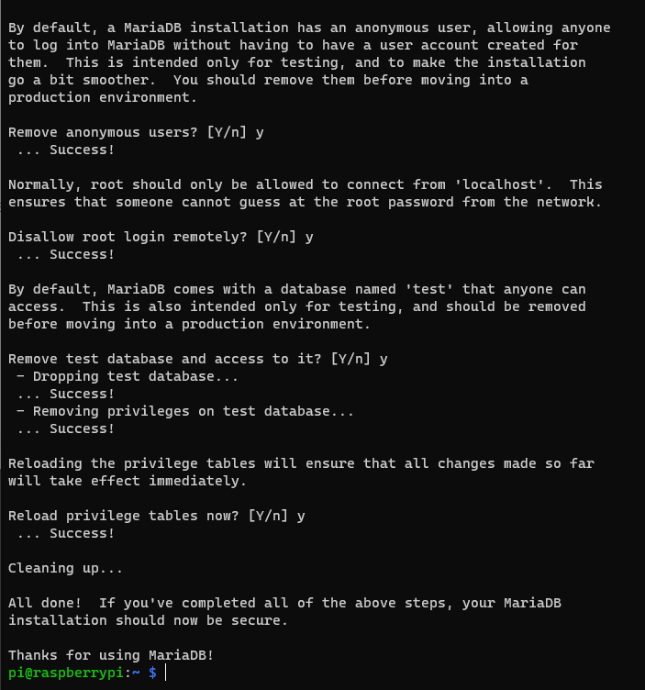

Afterwards we’re going to install phpMyAdmin, but this is optional. I prefer to install it, because I can edit the database in a web browser instead of in a terminal.

sudo apt-get install phpmyadmin

This screen should pop up:

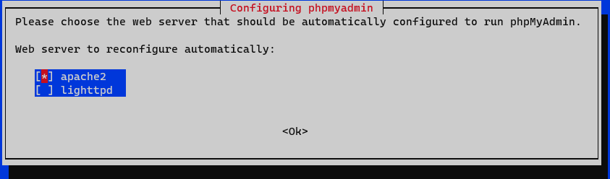

U only need to select apache2, and make sure it is selected by pressing ‘space’ and a star should appear. When it is selected press ‘enter’.

When this window appears, just select No.

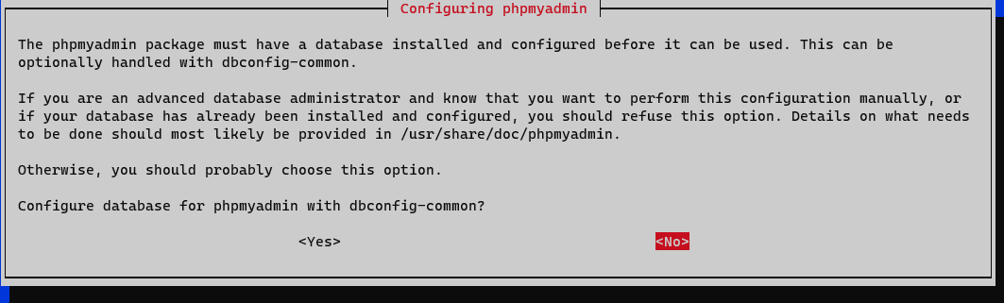

Now we’re going to make a user so we can log in. Type in the terminal:

sudo mysql -u root -p

Then:

CREATE USER 'username'@'localhost' IDENTIFIED BY 'password';

*Replace username and password by your own username and password*

Now we’re going to grant the user some privileges to edit the database, and then flush it.

GRANT CREATE, ALTER, DROP, INSERT, UPDATE, DELETE, SELECT, REFERENCES, RELOAD on *.* TO 'username'@'localhost' WITH GRANT OPTION;

FLUSH PRIVILEGES;

When it is all finished, you can go to <http://145.25.222.125/phpmyadmin> to configure the database. Make sure you’re connected with the network you’ve created earlier.

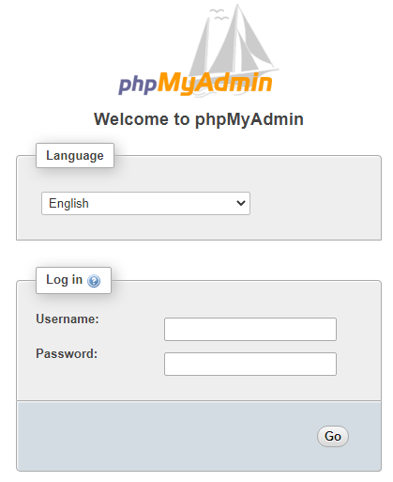

You’ll get this page, log in with the user you’ve just made.

Create a database named ‘senstable’.

Press SQL in the top bar. 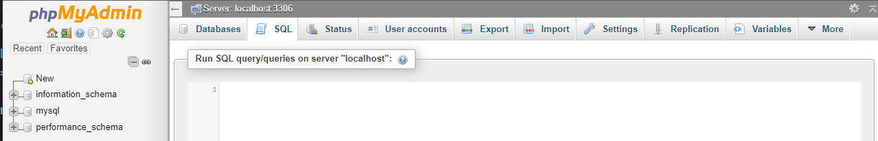

Then paste the given database in it and press run. There should now be a database added named “Senstable”.

